DATA UNDERSTANDING REPORT
Week 1 Deliverable (By Team 9)
RIT Opportunity-Wise Student Participation & Engagement Analysis
Academic Project Data Quality and Summary Analysis Report
Project Metadata | Details
Deliverable Title | Data Understanding Report
Dataset Source | RIT_STUDENT_DATA_FINAL.xlsx
Primary Worksheet | Cleaned_Data (8,558 rows x 16 columns)
Evaluation Criteria | Data Understanding (30%)  Documentation (20%)  Data Prep (20%)  Clarity (20%)  Quality (10%)

Contributors
Task Performed | Team Members
Data Cleaning | Ghufran Khan <iamghufrankhan1@gmail.com>  Victor Thompson <victor.thompsonva97@gmail.com>  Kamoru Olayemi Raji <Kamo4nice@gmail.com>
Data Quality and Summary Analysis  (Engagement Analysis) | Nour Ahmed <nourahmet77777@gmail.com>  Khadija Kamal <khadijakamal6002@gmail.com>  Barira Khan <khanbarira47@gmail.com>
Data Reporting | Khadija Kamal <khadijakamal6002@gmail.com>

1. Executive Summary
This report presents the Week 1 Data Understanding and Summary Analysis (or Engagement Analysis) of the Rochester Institute of Technology (RIT) Opportunity-Wise Student Participation Dataset. Program managers need to know which learning opportunities attract and keep student participation. This report is the first step: understanding and cleaning the data before any modelling. The primary objective is to evaluate dataset architecture, establish data quality standards, document variable definitions, analyze baseline participation patterns, and inspect continuous numeric distributions for outlier flags.
Key Analytical Takeaways
- Dataset Scope: The dataset contains 8,558 participation records across 16 variables, capturing student-level application and registration events for experiential learning opportunities.
- Core Offerings: Opportunity participation is heavily concentrated in Internships (63.34%, 5,421 records) and Courses (23.80%, 2,037 records), together accounting for 87.15% of all interactions.
- Application Outcomes: Out of 8,558 records, 41.70% (3,569) were Rejected and 38.28% (3,276) reached Team Allocated; only 8.96% (767) actually Started and 7.21% (617) Dropped Out. The other four statuses (Waitlisted, Applied, Withdraw, Rewards Award) make up the remaining 3.84% (329 records). These are outcomes, not ordered funnel stages.
- Outcomes by Category: All 3,569 Rejected records and 613 of the 617 Dropped Out records belong to Internships. Events, Competitions and Engagement activities mostly end as Team Allocated (84% to 97%), while Courses split between Team Allocated (54.7%) and Started (37.7%) (Section 5.3).
- Data Integrity: The dataset is 100% complete in 13 of 16 columns. Missing values are limited to Opportunity Start Date (3,794 rows, 44.33%), Current/Intended Major (0.06%) and Institution Name (0.05%). The missing start dates are explained by applications that never started (Rejected, Waitlisted, Applied); date columns needed day/month corrections (Section 4.2).
- Academic Profile: Participation is led by students in Information Systems (25.22%) and Computer Science (12.29%). Saint Louis University is the largest institution: 49.23% of records under its standard spelling, and about 52.62% once spelling variants are merged.
- Geography: Students come from 70 countries, led by the United States (46.46%), India (33.14%) and Nigeria (8.88%).
2. Understanding the Dataset & Methodology
2.1 Dataset Purpose & Granularity
The dataset records student-level applications and lifecycle transitions across experiential learning programs offered through RIT. Each row represents a single participation event (application/registration) submitted by a student for a specific opportunity.
- Total Observations: 8,558 rows
- Total Attributes: 16 columns (6 Datetime, 9 String, 1 Integer)
- Granularity: Student-Opportunity Level (multiple rows per student across different opportunities). There is no student ID; using First Name + Date of Birth as a proxy gives about 3,828 distinct students across 23 opportunities.
- Signup Date Range: 2023-01-05 to 2024-04-09 (15-month operational window).
2.2 Opportunity Categories
Opportunities are classified into 5 distinct categories representing different forms of student engagement (see Figure 1):
- Internship: Practical workplace and industry experience (5,421 records, 63.34%).
- Course: Structured skill-building modules and academic offerings (2,037 records, 23.80%).
- Event: Workshops, webinars, and informational sessions (545 records, 6.37%).
- Competition: Hackathons, innovation challenges, and project contests (425 records, 4.97%).
- Engagement: Community leadership and institutional engagement activities (130 records, 1.52%).
In total there are 23 opportunity IDs (22 distinct names): 9 Internships, 4 Courses, 3 Events, 5 Competitions and 2 Engagement opportunities.
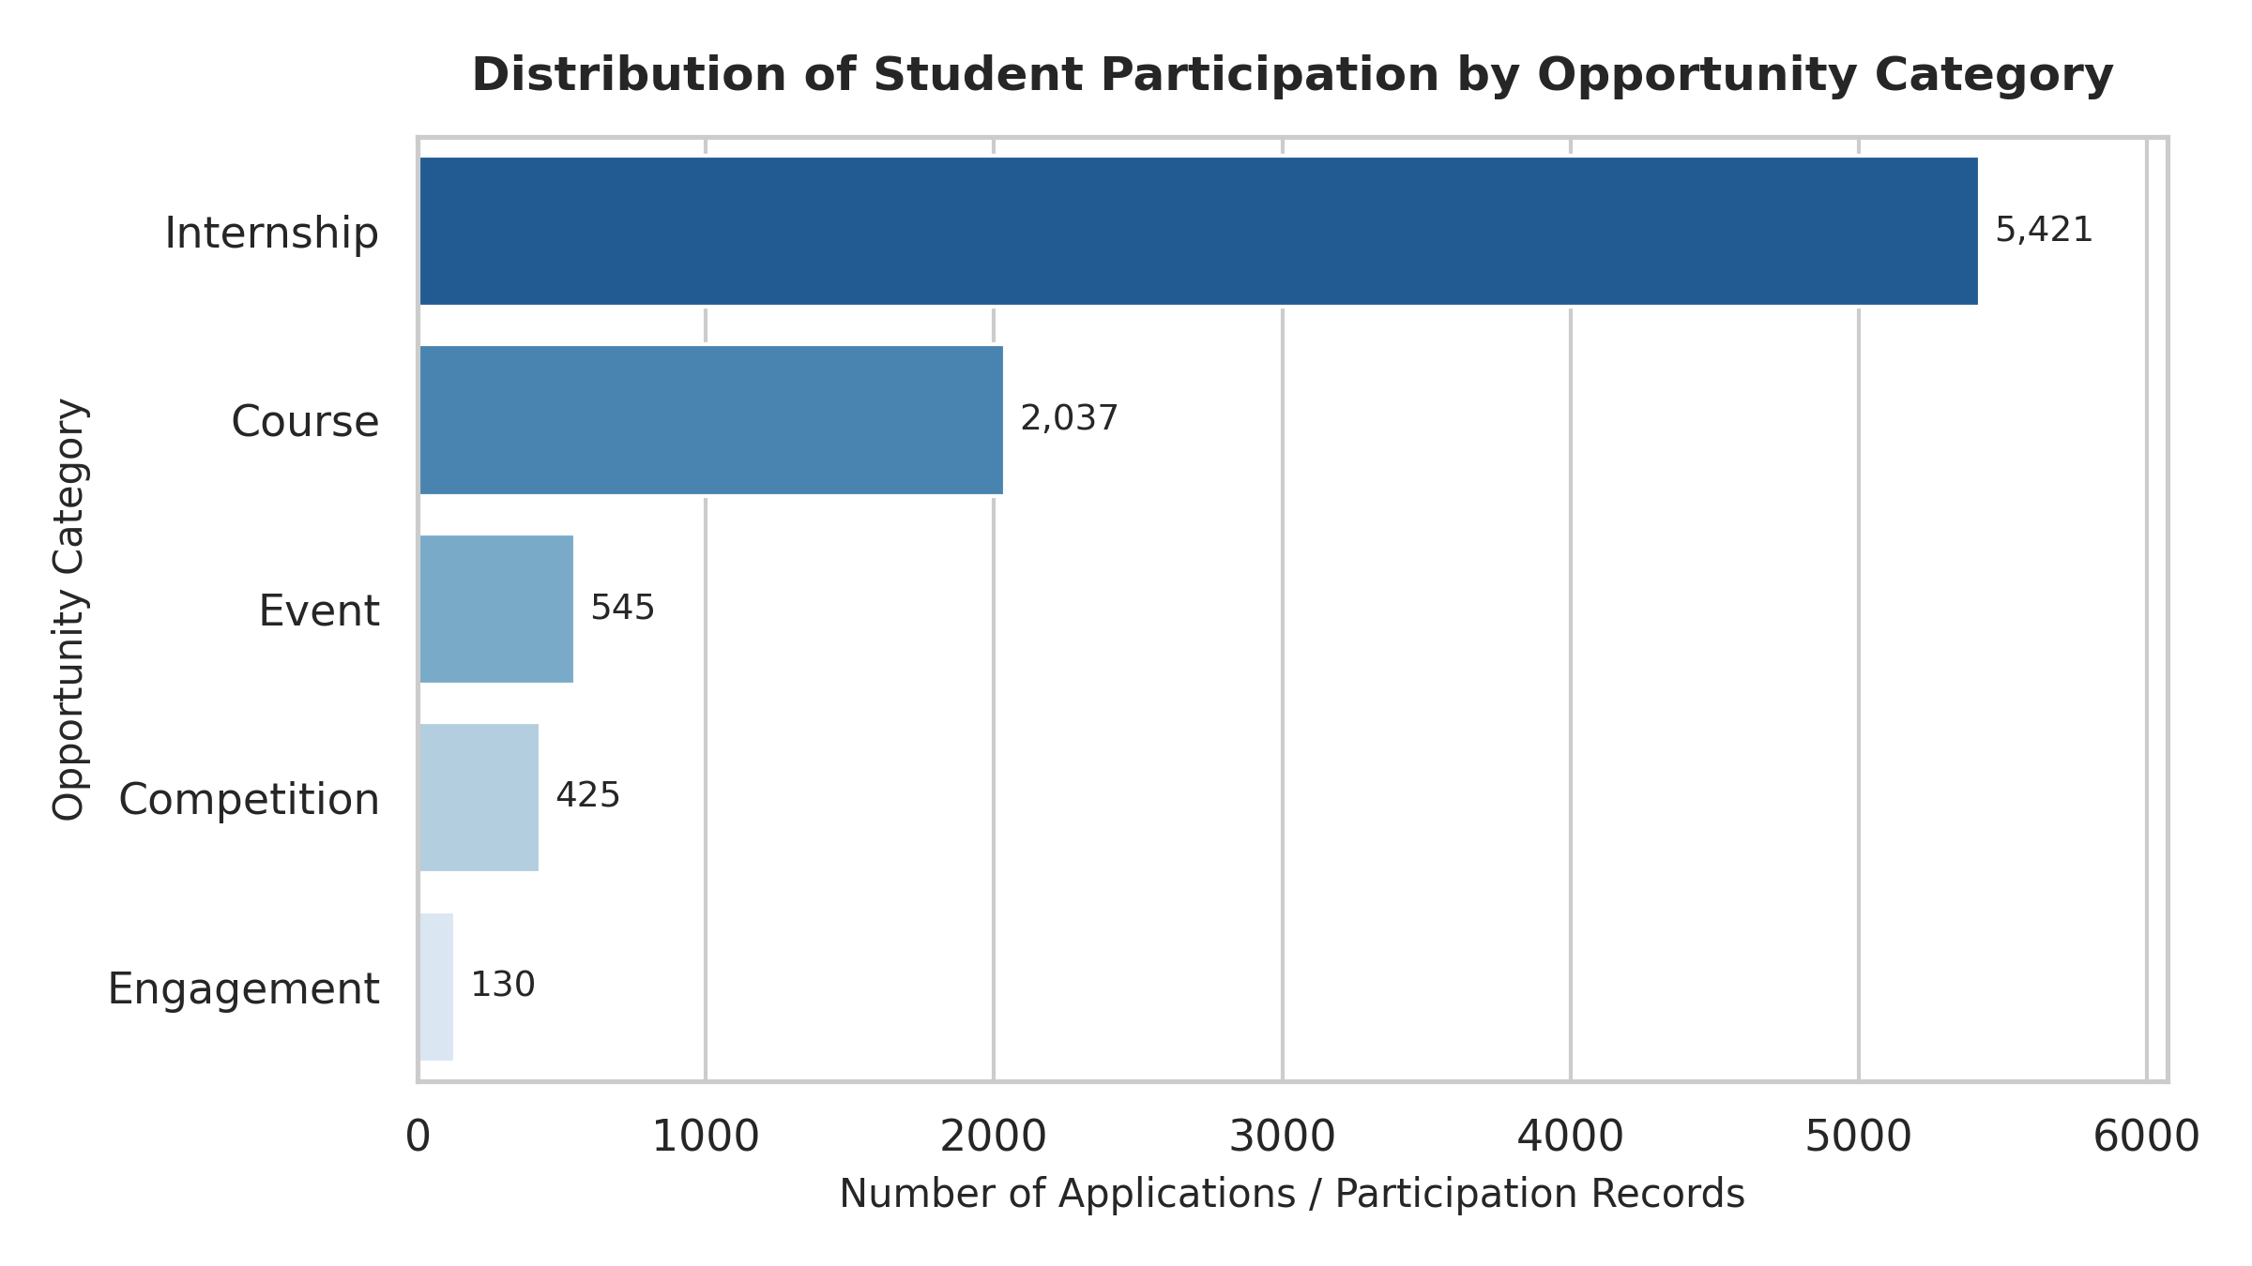
Figure 1: Student participation records by opportunity category.
3. Data Dictionary
The following data dictionary documents all 16 variables in the Cleaned_Data sheet. For each variable it gives the data type, the share of missing values, the number of distinct values, and a short description with its analytical role. Two column headers were renamed during cleaning: "Learner SignUp DateTime" became "Learner Signup Date", and "Entry created at" became "Entry Created At".
Column Name | Data Type | Missing % | Unique | Description & Analytical Role
Learner Signup Date | Datetime | 0.00% | 414 | Date the learner created their platform profile. Used for signup-timing and trend analysis.
Opportunity Id | String (30-character code) | 0.00% | 23 | Identifier of the opportunity. It repeats across rows (one value per opportunity, 23 in total), so it is not a unique row key. Used to group records by opportunity.
Opportunity Name | String | 0.00% | 22 | Full title of the course, internship, or event. There are 22 names for 23 IDs because one title (Jump Start: Developing your Emotional Intelligence) is shared by two IDs.
Opportunity Category | String | 0.00% | 5 | Classification of the opportunity (Internship, Course, Event, Competition, Engagement). Main grouping variable for participation analysis.
Opportunity End Date | Datetime | 0.00% | 16 | Scheduled end date of the program. Used with the Start Date to derive opportunity duration.
First Name | String | 0.00% | 2,897 | Learner first name. Used alongside Date of Birth as a student proxy because there is no student ID. Not needed for modelling.
Date of Birth | Datetime | 0.00% | 2,620 | Learner birth date. Used to derive age at application. Contains some implausible values (Section 4.4).
Gender | String | 0.00% | 4 | Gender as recorded (Male, Female, Other, Don't want to specify). Used for demographic profiling.
Country | String | 0.00% | 70 | Country recorded for the learner (70 distinct values). Used for geographic profiling.
Institution Name | String | 0.05% | 1,794 | Educational institution attended. Free text with many spelling variants; stored in upper case after cleaning.
Current/Intended Major | String | 0.06% | 406 | Learner's primary field of study. Used for academic profiling.
Entry Created At | Datetime (with time) | 0.00% | 94 | Record export timestamp: all values fall between 12:01:41 and 12:03:14 on 3 Nov 2024. Reference only; it is not the application time.
Status Description | String | 0.00% | 8 | Outcome of the application (for example Rejected, Started). Key outcome variable and the main candidate for the participation label in later weeks.
Status Code | Integer | 0.00% | 8 | System code that matches Status Description one-to-one (see Section 3.1).
Apply Date | Datetime | 0.00% | 442 | Date the learner formally submitted the application. Used for timing and lead-time analysis.
Opportunity Start Date | Datetime | 44.33% | 17 | Official start date of the program. Blank for the 3,794 applications that never started (see Section 4.1).
3.1 Status Code Mapping
Each Status Description maps to exactly one Status Code. Percentages are shares of all 8,558 records.
Status Code | Status Description | Records | % of Records
1010 | Applied | 105 | 1.23%
1030 | Rejected | 3,569 | 41.70%
1040 | Waitlisted | 109 | 1.27%
1050 | Dropped Out | 617 | 7.21%
1070 | Team Allocated | 3,276 | 38.28%
1080 | Started | 767 | 8.96%
1110 | Withdraw | 86 | 1.00%
1120 | Rewards Award | 29 | 0.34%

4. Initial Data Preparation & Quality Checks
4.1 Missing Values
A complete missingness assessment confirmed that:
- 13 out of 16 variables have 100% completeness.
- Opportunity Start Date has 3,794 missing rows (44.33%), which is structurally expected since non-started applications (e.g., Rejected, Waitlisted) do not have start dates.
- Missing values were left blank in the spreadsheet. In the analysis, missing Majors and Institutions are reported as "Unspecified", and rows without a Start Date are excluded from duration calculations. Start Dates are blank only for applications that never started: all 3,569 Rejected, 109 Waitlisted and 105 Applied rows are blank, and no Started or Team Allocated row is blank (11 Dropped Out/Withdraw rows are also blank).

4.2 Date and Time Problems and Fixes:
While inspecting the data, it was found that:
- 6 out of 16 variables are date-time related (Learner Signup Date, Opportunity End Date, Date of Birth, Entry Created At, Apply Date, Opportunity Start Date).
- Many values were stored as text instead of dates. For example, 5,364 of 8,558 Learner Signup Dates and all 5,175 text Dates of Birth were text such as 06/14/2023 (mm/dd/yyyy), while the remaining values were real dates.
- The times were inconsistent and often invalid: 2,707 text values in the four date-time columns had an hour of 24 or higher (some as large as 1084920:58:20).
- To fix this we removed the time from 5 of the 6 date-time columns, because the times were unreliable and added no analytical value. All five date columns are now true dates formatted dd/mm/yyyy.
- Entry Created At keeps its time, formatted dd/mm/yyyy hh:mm:ss. It is an export timestamp: all 8,558 values fall between 12:01:41 and 12:03:14 on 3 November 2024 (03/11/2024 in dd/mm/yyyy), so it does not show when a learner applied and is not used as an application time. The day/month swap was not applied to this column: if the swap were applied the export date would become 11 March 2024, which is earlier than applications made up to 10 April 2024, so 3 November 2024 is the more likely export date.
- Day and month were swapped in the real dates. Every real date had a day of 12 or less, while every text value had a day above 12 in the second position. This is the pattern produced when a mm/dd/yyyy source is read as dd/mm/yyyy. We swapped day and month back on 16,150 date values (those where day and month differ). After the correction, Apply Date is on or after Signup Date in 8,455 rows, compared with 7,745 before. This is an inference from the data and has not been confirmed by the data owner.
- Date of Birth: 5,175 text values were converted to dates, and the 3,383 real dates were corrected for the same day/month swap.
4.3 Corrupted Text (Mojibake) and Text Standardisation:
- Two columns, First Name and Institution Name, contained 48 corrupted cells (14 in First Name, 34 in Institution Name). This is mojibake: text in other languages and with accents (Arabic, Chinese, Hindi, Korean, Russian, Vietnamese, Turkish, French and others) was stored as UTF-8 but read with a different character set (Mac Roman), producing symbols such as ÈïøÊ≤ôÂ≠¶Èô¢ instead of 长沙学院.
- We used the AI tool Claude to reverse the encoding. Each cell was re-encoded and decoded correctly, which restored the original text in all 48 cells. The restored non-English names and institutions were then converted to English (names transliterated, institution names translated, accents removed). The original text remains in the Raw_Data sheet.
- Extra spaces: double or edge spaces were removed from 258 Institution Name cells, 3 Country cells and 2 First Name cells (e.g. "FEDERAL UNIVERSITY LOKOJA"), so names that differed only by spacing now count as one institution.
- Country spelling: 3 cells written "Iran Islamic Republic Of Persian Gulf" were changed to match the other 6, "Iran, Islamic Republic Of Persian Gulf".
- Text case: Institution Name was converted to upper case and First Name to proper case, so the same text written in different cases counts as one value (8,086 Institution Name and 739 First Name cells differ from the raw sheet, including the fixes above). Country capitalisation was also tidied in 28 cells (for example "of" became "Of"), which includes the 3 Iran cells above.
4.4 Invalid Values Present in the Dataset:
- Besides the problems fixed above, we found other invalid or doubtful values that we did not change, as they are outside our scope:
  - Invalid First Names (single character, or number/underscores in the name)
  - Invalid Institution names (single character, or even a Gmail ID typed in the field).
  - Non-institution text: one Institution Name contains map-copyright text ("© 2023 TOMTOM © OPENSTREETMAP …") copied into the field. It was left unchanged.
  - Test accounts: 15 rows have test-style first names (for example Manish3Test3, Navnath3Test3, Yash3Test3 and Test). They look like test entries, not real learners, and were left in place. "Testimony" is a real name and was not counted.
  - Possible duplicates: 4 pairs of rows (8 rows) are identical in every column except Entry Created At, which differs by a few seconds. Without a student ID we cannot be sure they are the same person, so they were kept.
  - Date of birth: some entries are practically impossible. One learner (birth year 2019) was about 3.7 years old when applying, and 81 learners (0.95%) were under 16 at application, 7 of them under 13. Eleven learners are almost exactly 13.0 years old at application, which may be a default entered to pass a minimum-age rule (unconfirmed).
- Because of this ambiguity we neither changed the values nor deleted the rows; they are flagged in Section 4.5.
For full complete detail regarding data cleaning, Check out this documentation:
Data Cleaning Documentation.

4.5 Data Quality & Anomaly Assessment
Issue / Anomaly | Scope / Rows | Root Cause | Analytical Treatment
Missing Start Dates | 3,794 rows (44.33%) | Unenrolled/Rejected applications | Retain; exclude from start checks
Pre-Signup Applications | 103 rows (1.20%) | Likely data backfilling/system lag (unconfirmed) | Flagged; documented as system lag
Negative Opportunity Duration | 116 rows (1.36%) | Likely data entry or end-date error (unconfirmed) | Filtered out in duration calculations
Underage Observations (<16 at application) | 81 rows (0.95%); 7 under 13 | Implausible or default birth dates (unconfirmed) | Flagged in age outlier analysis
Missing Majors/Institutions | 9 rows (<0.10%) | Optional user fields | Categorized as 'Unspecified'
Possible Duplicates | 4 pairs (8 rows) | Same record logged twice a few seconds apart (likely) | Flagged and retained
Test Accounts | 15 rows (0.18%) | Test entries such as Manish3Test3 | Flagged; exclude in later analysis
Institution Spelling Variants | Saint Louis University: 4,503 rows under many spellings | Free-text entry | Merged by pattern for reporting only
Extra Spaces / Iran Spelling | 263 + 3 cells | Manual entry | Fixed (Section 4.3)
Day/Month Swapped Dates | 16,150 date values | mm/dd/yyyy source read as dd/mm/yyyy | Fixed (Section 4.2)
Text Case Standardisation | Institution Name (8,086 cells), First Name (739), Country (28) | Free-text entry in mixed case | Fixed (Section 4.3)
Non-Institution Text | 1 row (map copyright text) | Copy-paste into a free-text field | Flagged; left unchanged

5. Descriptive Statistics & Participation Patterns
Analysis of participation patterns reveals concentrations across opportunity types, application outcomes, geography, institutions and academic disciplines. The charts (Figures 2 to 4) appear next to the results they support.
5.1 Longitudinal Signup Trends
Signup activity peaked in January 2024 (1,547 records, 18.08%), followed by August 2023 (1,143, 13.36%) and February 2024 (1,075, 12.56%); see Figure 2. These counts are application records grouped by signup month, not unique accounts. The data does not state the cause of the peaks, so they should not be attributed to any reason without further evidence.
The low counts for March and April 2024 (133 and 12 records) most likely reflect the end of the data window: the latest Apply Date is 10 April 2024. They should not be read as a real fall in interest.
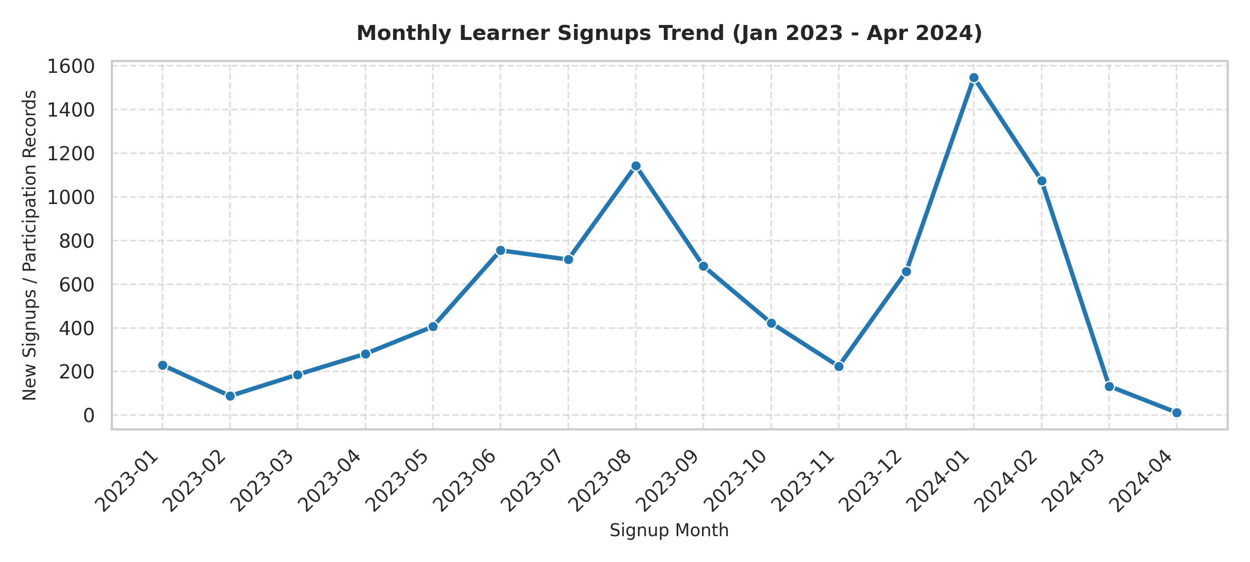
Figure 2: Monthly learner signups, January 2023 to April 2024 (application records grouped by signup month).
5.2 Application Outcomes
All 8 status values map one-to-one to a status code. Counts are shares of all 8,558 records:
- Rejected: 3,569 records (41.70%).
- Team Allocated: 3,276 records (38.28%).
- Started: 767 records (8.96%).
- Dropped Out: 617 records (7.21%).
- Waitlisted: 109 records (1.27%).
- Applied: 105 records (1.23%).
- Withdraw: 86 records (1.00%).
- Rewards Award: 29 records (0.34%).
These statuses are outcomes, not strictly ordered stages, so they are not read as a conversion funnel.
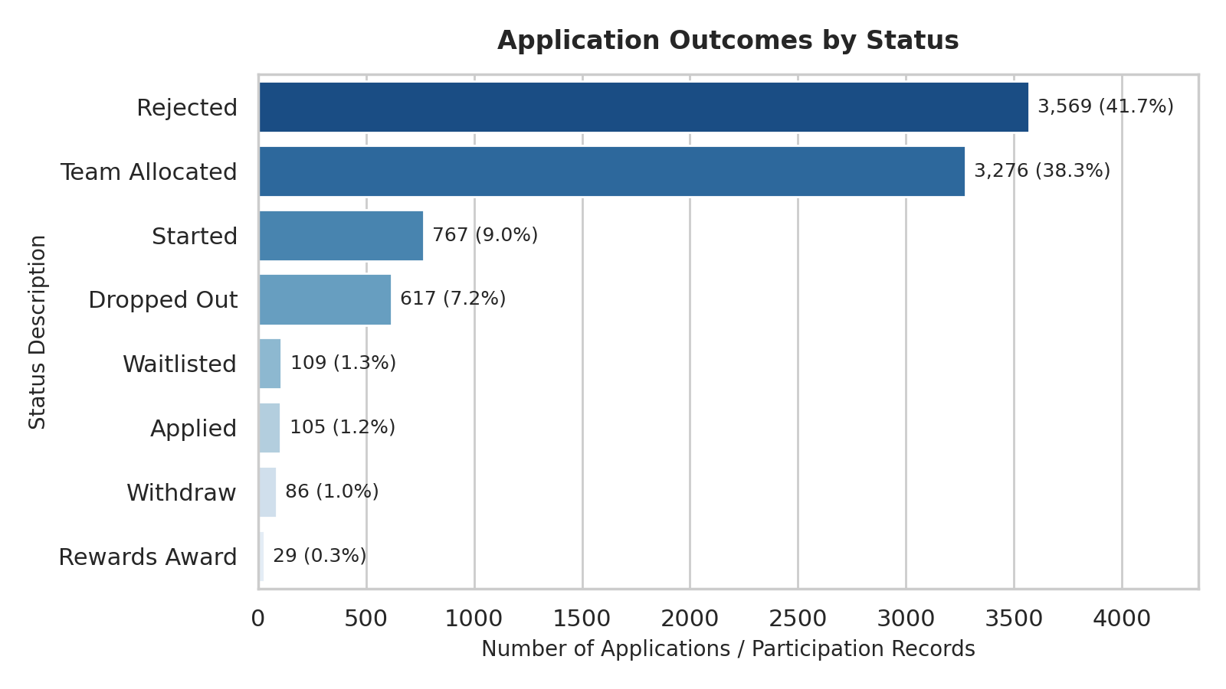
Figure 3: Application outcomes by status (number of records and share of all 8,558 records).
5.3 Opportunity Category Analysis
Table 5.3 and Figure 4 show how outcomes are spread within each opportunity category. Each percentage is a share of that category's own records, so categories of different sizes can be compared. "Other" combines Applied, Waitlisted, Withdraw and Rewards Award.
Category | Records | Rejected | Dropped Out | Team Allocated | Started | Other
Internship | 5,421 | 65.8% | 11.3% | 21.5% | 0.0% | 1.4%
Course | 2,037 | 0.0% | 0.0% | 54.7% | 37.7% | 7.7%
Event | 545 | 0.0% | 0.0% | 94.1% | 0.0% | 5.9%
Competition | 425 | 0.0% | 0.9% | 84.2% | 0.0% | 14.8%
Engagement | 130 | 0.0% | 0.0% | 96.9% | 0.0% | 3.1%

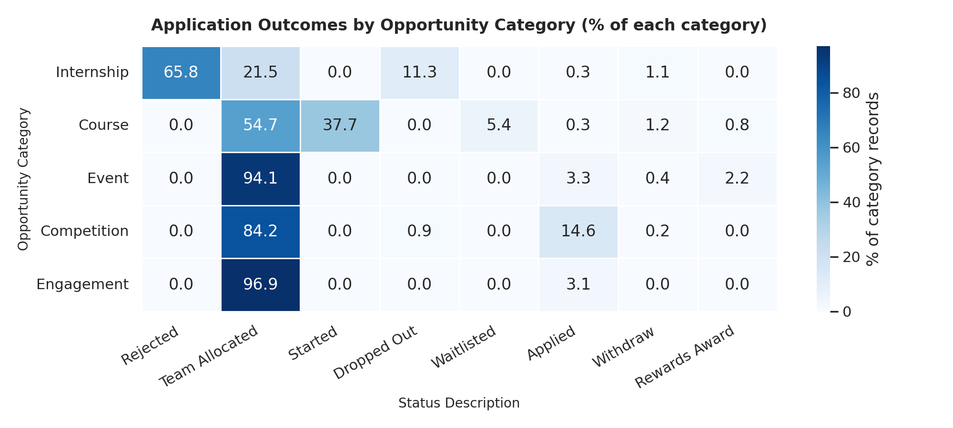
Figure 4: Application outcomes by opportunity category (% of each category's records).
- Internships: Internships hold 63.3% of all records but all 3,569 Rejected records and 613 of the 617 Dropped Out records (99.4%). Only 21.5% of internship records ended as Team Allocated.
- Courses: Courses are the only category with Started records (767, or 37.7%) and with Waitlisted records (109, or 5.4%). Most of the rest are Team Allocated (54.7%).
- Events, Competitions and Engagement: These mostly end as Team Allocated (94.1%, 84.2% and 96.9%). Competitions have the largest share still at Applied (14.6%).
- Caution: Status labels appear to be used differently by category (for example, only Internships have Rejected records and only Courses have Started records). Comparisons across categories are therefore indicative, and the meaning of each status should be confirmed with the data owner.
5.4 Opportunity-Level Outcomes
The table below lists all 22 opportunity names, from the largest to the smallest by number of records. Percentages are shares of each opportunity's own records.
Opportunity | Category | Records | Rejected | Dropped Out | Team Alloc. | Started | Other
Career Essentials: Getting Started with Your Professional Journey | Course | 1,423 | 0.0% | 0.0% | 47.9% | 46.0% | 6.1%
Data Visualization | Internship | 980 | 63.3% | 22.6% | 12.8% | 0.0% | 1.4%
Project Management | Internship | 836 | 65.1% | 20.3% | 12.8% | 0.0% | 1.8%
Health Care Management | Internship | 784 | 42.1% | 0.0% | 54.8% | 0.0% | 3.1%
Digital Marketing | Internship | 559 | 65.5% | 22.7% | 11.4% | 0.0% | 0.4%
Data Visualization Associate | Internship | 551 | 77.0% | 0.0% | 22.0% | 0.0% | 1.1%
Business Consulting | Internship | 483 | 82.8% | 0.0% | 16.1% | 0.0% | 1.0%
Project Management Associate | Internship | 478 | 77.4% | 0.0% | 22.4% | 0.0% | 0.2%
Innovation & Entrepreneurship | Internship | 419 | 62.3% | 22.7% | 14.3% | 0.0% | 0.7%
CPR/AED Certification | Course | 389 | 0.0% | 0.0% | 56.3% | 28.0% | 15.7%
Digital Strategy Virtual Internship | Internship | 331 | 76.7% | 0.0% | 22.1% | 0.0% | 1.2%
Startup Mastery Workshop | Event | 262 | 0.0% | 0.0% | 94.7% | 0.0% | 5.3%
Freelance Mastery workshop | Event | 237 | 0.0% | 0.0% | 93.7% | 0.0% | 6.3%
Jump Start: Developing your Emotional Intelligence | Course | 225 | 0.0% | 0.0% | 94.7% | 1.8% | 3.6%
UrbanRenew Challenge | Competition | 138 | 0.0% | 0.0% | 97.8% | 0.0% | 2.2%
Join a Student Organisation | Engagement | 121 | 0.0% | 0.0% | 97.5% | 0.0% | 2.5%
Xperience Design Hackathon | Competition | 116 | 0.0% | 0.0% | 97.4% | 0.0% | 2.6%
UX Redesign Challenge | Competition | 112 | 0.0% | 0.0% | 98.2% | 0.0% | 1.8%
AI Ethics Challenge | Competition | 55 | 0.0% | 0.0% | 0.0% | 0.0% | 100.0%
Mental and Physical Health Session | Event | 46 | 0.0% | 0.0% | 93.5% | 0.0% | 6.5%
Upload Your First Year Transcript | Engagement | 9 | 0.0% | 0.0% | 88.9% | 0.0% | 11.1%
Slide Geeks: A Presentation Design Competition | Competition | 4 | 0.0% | 100.0% | 0.0% | 0.0% | 0.0%

- Largest opportunity: Career Essentials: Getting Started with Your Professional Journey (a Course) has 1,423 records, or 16.6% of the dataset.
- Internship rejection: Rejection rates range from 42.1% (Health Care Management) to 82.8% (Business Consulting).
- Internship drop-out: Drop-outs are concentrated in four internships (Data Visualization, Project Management, Digital Marketing, and Innovation & Entrepreneurship), where about 20% to 23% of records are Dropped Out. The other five internships have none.
- Open or unusual cases: All 55 records of the AI Ethics Challenge have the status Applied, and all 4 records of the Slide Geeks competition are Dropped Out. These two cases are worth checking with the program team.
5.5 Geography and Gender
- Countries: 70 countries are represented: United States 3,976 (46.46%), India 2,836 (33.14%), Nigeria 760 (8.88%), Ghana 275 (3.21%) and Pakistan 219 (2.56%).
- Gender: Male 58.64%, Female 41.15%, Don't want to specify 0.18% and Other 0.04%.
5.6 Institutions and Majors
- Institutions: Saint Louis University has 4,213 records (49.23%) under its standard spelling. With spelling variants merged (e.g. SAINT LOUIS, ST LOUIS UNIVERSITY, SLU) it rises to about 4,503 records (52.62%). The next largest are Illinois Institute of Technology (152 records, 1.78%) and Webster University (72 records, 0.84%).
- Majors: Information Systems 25.22%, Computer Science 12.29%, Health Data Science 4.34%, Cyber Security 3.81% and Computer Information Systems 2.92%, out of 406 distinct majors.
6. Distribution, Skewness, and Outlier Detection
Three continuous derived variables were evaluated for distributional properties, skewness and IQR outliers: learner age at application (Apply Date minus Date of Birth), days from signup to application, and opportunity duration. Figure 5 shows the age distribution.
Metric Variable | Count | Mean | Std | Min | 25% | Median | 75% | Max | Skewness
Learner Age at Application (Years) | 8,558 | 24.14 | 4.38 | 3.67 | 21.90 | 23.42 | 25.34 | 57.54 | +1.95 (Right)
Application Lead (Days) | 8,558 | 56.27 | 88.96 | -98.0 | 0.00 | 4.00 | 91.00 | 427.0 | +1.63 (Right)
Opportunity Duration (Days) | 4,764 | 287.09 | 286.13 | -24.0 | 49.00 | 95.00 | 604.00 | 913.0 | +0.41 (Approx. Symmetric)

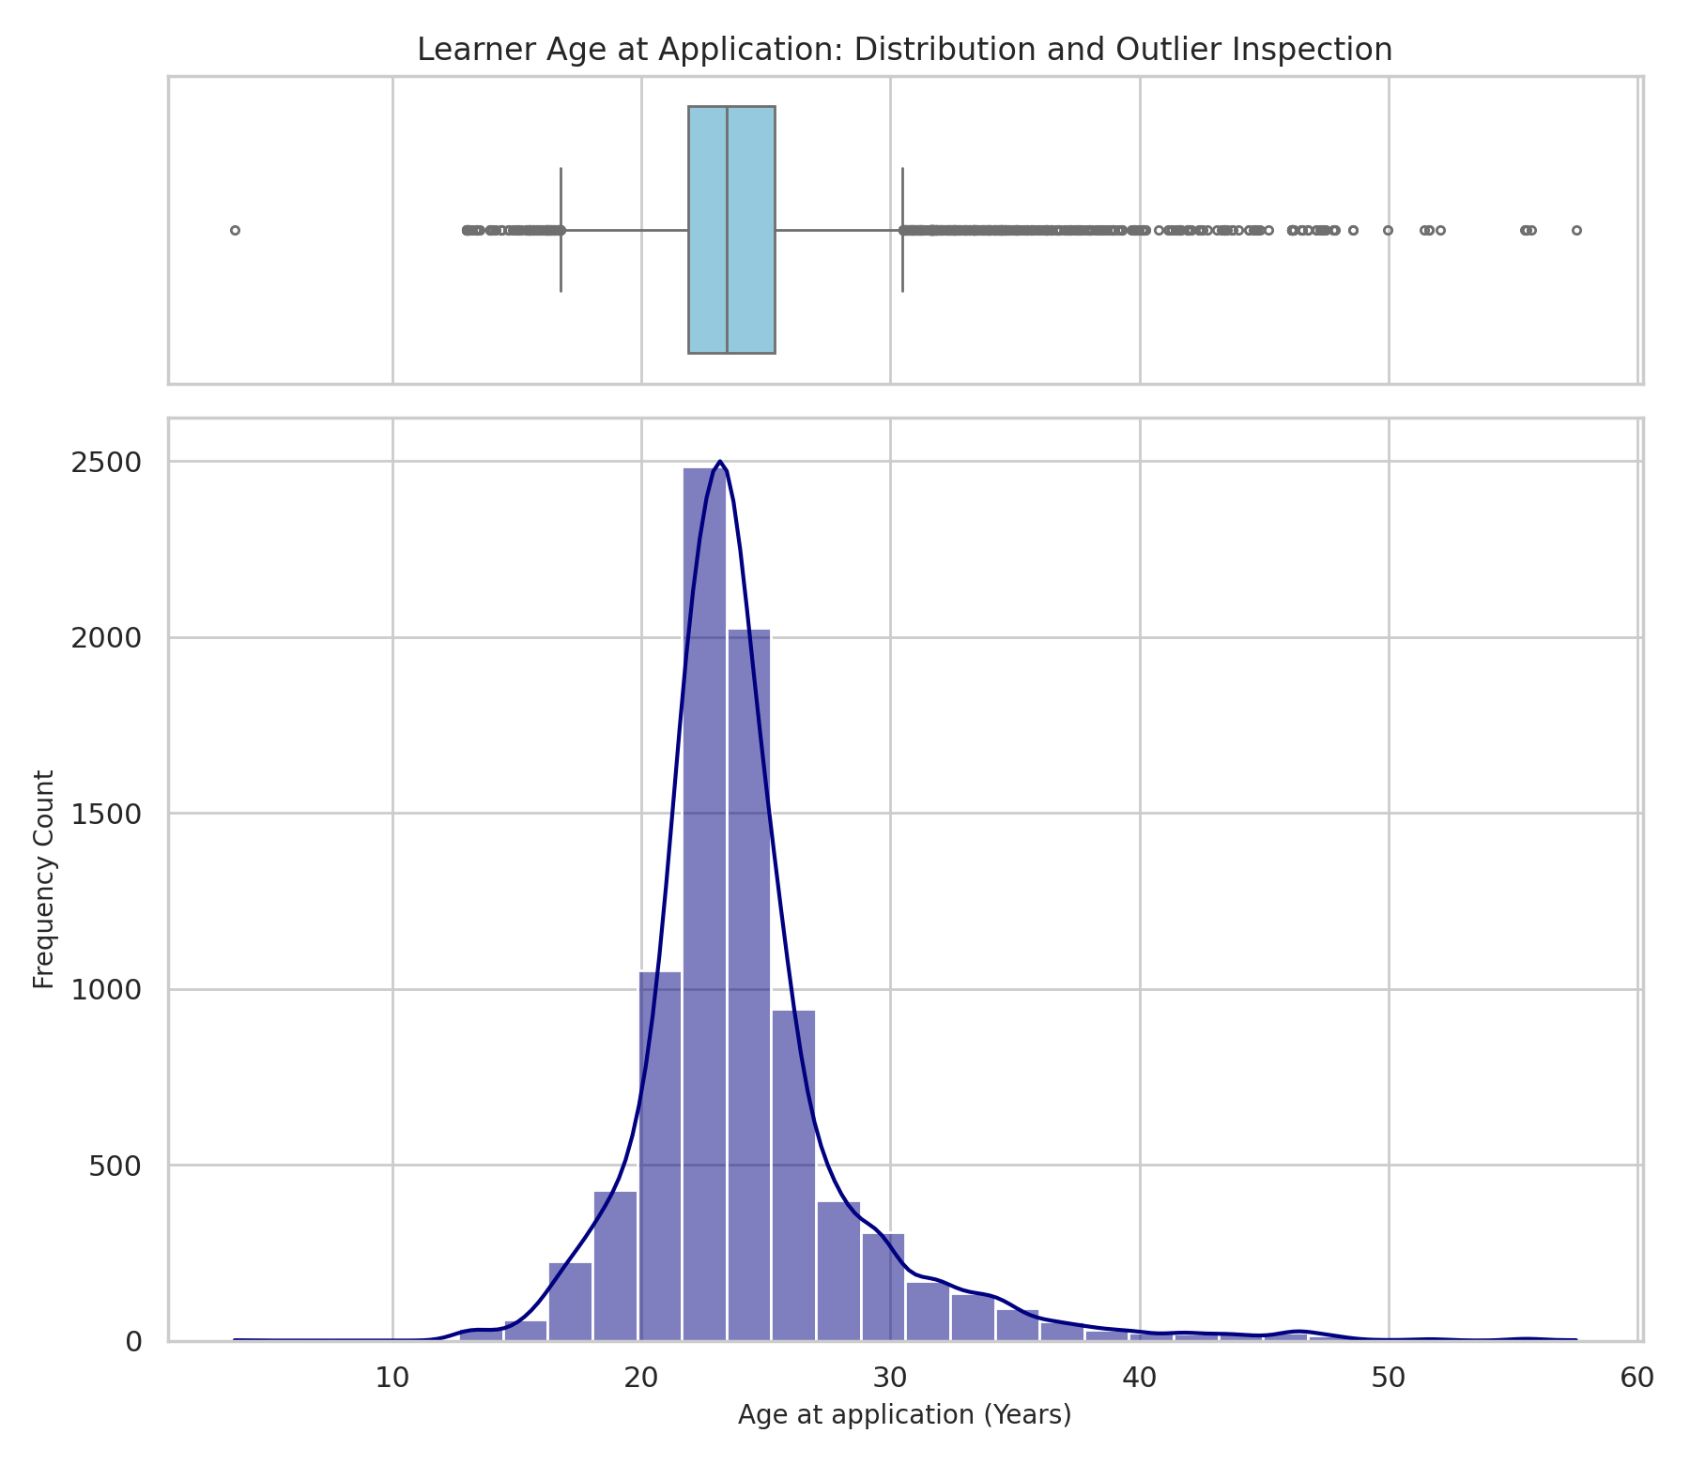
Figure 5: Learner age at application, boxplot and histogram. Age is measured at the Apply Date.
6.1 IQR Outlier Analysis
- Learner Age at Application (Years):
- Q1=21.90
- Q3=25.34
- IQR=3.44.
- Fences: [16.74, 30.50].
- Outliers: 752 records (8.79%).
- Represents mature learners (>30.5 years: 607 records) and very young learners (<16.7 years: 145 records), the latter likely including placeholder birth dates.

- Application Lead Time (Days):
- Q1=0.0
- Q3=91.0
- IQR=91.0
- Fences: [-136.5, 227.5]
- Outliers: 566 records (6.61%).
- Represents long-standing account holders applying >7.5 months post-signup.

- Opportunity Duration (Days):
- Q1=49.0
- Q3=604.0
- IQR=555.0
- Fences: [-783.5, 1436.5]
- Outliers: 0 records (0.00%).
- Note: the IQR method cannot detect impossible values. Negative lead times (103 rows) and negative durations (116 rows) lie inside the fences, so they were found with the logical checks in Section 4.5.
7. AI Disclosure
7.1 In Data Cleaning
- In Sections 4.2 and 4.3 (date fixes, mojibake and text standardisation), we used the AI tool Claude to edit the spreadsheet. The first prompt is quoted below. Later prompts asked it to convert Date of Birth to dates, correct the day/month swap, format Entry Created At, translate the corrected text to English, and fix extra spaces and the Iran spelling.
- Claude also reviewed this report against the data. The corrections in the earlier version include age measured at the application date, the outcome percentages, the notes on duplicates and test accounts, and the added sections on application outcomes, geography, institutions and majors.
- Prompt: “In this document, you have to do two things: In the columns "Learner Signup Date","Opportunity End Date","Apply Date", and "Opportunity Start Date", format all the values in these columns to date and set the format to dd/mm/yyyy. Second, in some cells of this spreadsheet document there are some mojibake characters, broken text characters are there. And I got to know that these are just distorted text of other language decoded by the wrong encoder. I don't know how many of them are actually considered mojibake or something like that. But I got to know that we can actually convert such broken character to actual readable text, you have to find out all those distorted text and make it actually readable and do the correct translation of each”
7.2 In Refining the Code, and Formatting Tables in Report
- The code in Appendix A was first refined with Gemini, then rewritten and tested against the data with Claude so that it reproduces every figure in this report.
- Also the tables in this report are formatted by Gemini.
7.3 In Reviewing and Revising this Report
- Claude reviewed the first version of this report against the Raw_Data and Cleaned_Data sheets, checked the numbers, and listed what to improve. It then applied those fixes in this version: the opportunity category and opportunity-level analysis (Sections 5.3 and 5.4), Figures 3 and 4, the expanded data dictionary and status code table, the extra cleaning notes, the program recommendations and the conclusion.
- Prompt (summary): asked Claude to review the report against the raw and cleaned worksheets, using simple and professional language, with a lenient rather than strict approach.
- Prompt (summary): asked Claude to apply the suggested fixes to the same Word file and theme, and to export the final corrected report.
7.4 Summary of AI Use
Section | AI Tool | Use | Insight / Result
4.2 Date fixes | Claude | Converted text dates to real dates in dd/mm/yyyy format and corrected the day/month swap. | 16,150 date values corrected. Apply Date is on or after Signup Date in 8,455 rows (7,745 before).
4.3 Text cleaning | Claude | Reversed mojibake, translated restored text to English, removed extra spaces and fixed the Iran spelling. | 48 corrupted cells restored; 263 spacing fixes; 3 Iran cells corrected.
Appendix A and tables | Gemini, then Claude | Code refined with Gemini, then rewritten and tested with Claude; tables formatted by Gemini. | Script reproduces every table, count and chart in this report.
Whole report | Claude | Checked the numbers against the data, listed fixes and applied them. | Added Sections 5.3 and 5.4, Figures 3 and 4, dictionary additions and the conclusion.

8. Limitations & Recommendations
8.1 Limitations
- Identifier Scope: Lack of a primary Student_ID hash requires proxy matching using First Name and Date of Birth.
- Text Heterogeneity: Free-text institution names contain many spelling variants (e.g., SAINT LOUIS UNIVERSITY vs ST LOUIS UNIVERSITY). Saint Louis University is 49.23% under its standard spelling but about 52.62% once variants are merged.
- Inferred Date Correction: Day and month were swapped back on 16,150 date values based on the pattern in the data. The data owner has not confirmed the original date format.
- Duplicates and Test Accounts: 4 possible duplicate pairs and 15 test rows remain in the data and may slightly inflate counts.
- Export Timestamp: Entry Created At is an export time, so the real time of application is not available.
- Status Meaning: Status labels appear to be used differently by category (for example, only Courses have Started records and only Internships have Rejected records), so comparisons across categories are indicative only.
8.2 Recommendations for Subsequent Analytics
- Data Standardization: Apply fuzzy string matching to standardize institutional names prior to multi-university benchmarking.
- Funnel Optimization: Formalize conversion funnels (Applied -> Team Allocated -> Started) across specific majors and categories.
- Input Restriction: Restrict the users to put only valid values of variables in input box of application form to avoid further problem regarding formatting and data validation.
- Source Confirmation: Confirm the original date format with the data owner and export dates as real date values rather than text.
8.3 Recommendations for Program Managers
- Review internship outcomes: Internships have the highest rejection (65.8%) and drop-out (11.3%) rates. Review the four internships with about 20% to 23% drop-out (Data Visualization, Project Management, Digital Marketing, and Innovation & Entrepreneurship) and compare them with Health Care Management, which has the lowest rejection rate (42.1%) and no drop-outs.
- Follow up on open applications: Competitions have 14.6% of records still at Applied, including all 55 records of the AI Ethics Challenge. Confirm whether these applications were processed.
- Understand signup peaks before planning outreach: Signups peaked in January 2024, August 2023 and February 2024. The data does not give the cause, so Week 2 should examine what drives these peaks.
- Confirm status definitions: Agree with the data owner what each status means in each category, so that later models treat them consistently.
9. Conclusion
The dataset has 8,558 records, 16 columns and 23 opportunities. After cleaning, it is ready for the Week 2 exploratory analysis. The main findings are that Internships make up 63.3% of participation and account for all rejections and almost all drop-outs, that the other categories mostly end as Team Allocated, and that signups peak in August 2023 and January to February 2024.
Remaining issues (possible duplicates, test accounts, implausible birth dates, applications before signup, and the inferred date correction) are flagged and documented, not hidden. Week 2 will build on this foundation by exploring signup timing, opportunity type and duration against participation.
Appendix A: Reproducible Python Analysis Script
The script below runs as a normal script (no notebook needed). It was tested against the Cleaned_Data sheet of RIT_STUDENT_DATA_FINAL.xlsx and reproduces every table, count and chart in this report (Figures 1 to 5). Charts are saved in a folder named output_assets.
import os

import numpy as np
import pandas as pd
import matplotlib.pyplot as plt
import seaborn as sns

# ---------------------------------------------------------------
# Setup
# ---------------------------------------------------------------
pd.set_option("display.max_columns", None)
pd.set_option("display.width", 1000)
sns.set_theme(style="whitegrid")

output_dir = "output_assets"
os.makedirs(output_dir, exist_ok=True)

file_path = "RIT_STUDENT_DATA_FINAL.xlsx"
xls = pd.ExcelFile(file_path)
print("Worksheet Names:", xls.sheet_names)

df = pd.read_excel(file_path, sheet_name="Cleaned_Data")
n = len(df)
print(f"Dataset Shape: {n:,} rows x {df.shape[1]} columns")

# ---------------------------------------------------------------
# 1. Schema, missingness and uniqueness
# ---------------------------------------------------------------
schema_summary = pd.DataFrame(
{
"Data Type": df.dtypes,
"Non-Null Count": df.notnull().sum(),
"Null Count": df.isnull().sum(),
"Null Percentage (%)": df.isnull().sum() / n * 100,
"Unique Values": df.nunique(),
}
)
print(schema_summary)

# ---------------------------------------------------------------
# 2. Duplicate checks
# ---------------------------------------------------------------
print("Exact Duplicate Rows:", df.duplicated().sum())

# Near-duplicates: identical except for the Entry Created At time stamp
key_cols = [c for c in df.columns if c != "Entry Created At"]
near_dups = df[df.duplicated(subset=key_cols, keep=False)]
print("Rows in near-duplicate groups:", len(near_dups))

# Test accounts (e.g. Manish3Test3) - 'Testimony' is a real name
test_mask = df["First Name"].astype(str).str.contains(r"^Test$|\dTest\d", regex=True)
print("Test-account rows:", test_mask.sum())

# Student proxy (no student ID exists in the data)
print("Distinct students (First Name + DOB):",
df[["First Name", "Date of Birth"]].drop_duplicates().shape[0])

# ---------------------------------------------------------------
# 3. Status code mapping and application outcomes (Figure 3)
# ---------------------------------------------------------------
status_mapping = (
df.groupby(["Status Code", "Status Description"]).size().reset_index(name="Record Count")
)
print(status_mapping)

status_summary = df["Status Description"].value_counts().reset_index()
status_summary.columns = ["Status Description", "Record Count"]
status_summary["Percentage (%)"] = status_summary["Record Count"] / n * 100
print(status_summary)

# Start dates should be missing only for applications that never started
print(df.groupby("Status Description")["Opportunity Start Date"].apply(lambda s: s.isna().sum()))

plt.figure(figsize=(8, 4.5))
ax3 = sns.barplot(
data=status_summary, x="Record Count", y="Status Description",
hue="Status Description", palette="Blues_r", legend=False,
)
plt.title("Application Outcomes by Status", fontsize=12, fontweight="bold", pad=12)
plt.xlabel("Number of Applications / Participation Records", fontsize=10)
plt.ylabel("Status Description", fontsize=10)
for p, pct in zip(ax3.patches, status_summary["Percentage (%)"]):
width = p.get_width()
ax3.annotate(f"{int(width):,} ({pct:.1f}%)", (width + 40, p.get_y() + p.get_height() / 2.0),
ha="left", va="center", fontsize=9)
plt.xlim(0, status_summary["Record Count"].max() * 1.22)
plt.tight_layout()
plt.savefig(os.path.join(output_dir, "fig3_application_outcomes.png"), dpi=200)
plt.close()

# ---------------------------------------------------------------
# 4. Opportunity categories (Figure 1)
# ---------------------------------------------------------------
cat_summary = df["Opportunity Category"].value_counts().reset_index()
cat_summary.columns = ["Opportunity Category", "Record Count"]
cat_summary["Percentage (%)"] = cat_summary["Record Count"] / n * 100
print(cat_summary)

plt.figure(figsize=(8, 4.5))
ax1 = sns.barplot(
data=cat_summary, x="Record Count", y="Opportunity Category",
hue="Opportunity Category", palette="Blues_r", legend=False,
)
plt.title("Distribution of Student Participation by Opportunity Category",
fontsize=12, fontweight="bold", pad=12)
plt.xlabel("Number of Applications / Participation Records", fontsize=10)
plt.ylabel("Opportunity Category", fontsize=10)
for p in ax1.patches:
width = p.get_width()
ax1.annotate(f"{int(width):,}", (width + 50, p.get_y() + p.get_height() / 2.0),
ha="left", va="center", fontsize=9)
plt.xlim(0, cat_summary["Record Count"].max() * 1.12)
plt.tight_layout()
plt.savefig(os.path.join(output_dir, "fig1_opportunity_categories.png"), dpi=300)
plt.close()

# ---------------------------------------------------------------
# 5. Opportunity category analysis (Figure 4) and opportunity-level outcomes
# ---------------------------------------------------------------
cat_order = cat_summary["Opportunity Category"].tolist()
status_order = status_summary["Status Description"].tolist()

cat_status = pd.crosstab(df["Opportunity Category"], df["Status Description"])
cat_status = cat_status.loc[cat_order, status_order]
cat_status_pct = cat_status.div(cat_status.sum(axis=1), axis=0) * 100
print(cat_status)
print(cat_status_pct.round(1))

plt.figure(figsize=(10, 4.5))
sns.heatmap(cat_status_pct, annot=True, fmt=".1f", cmap="Blues", linewidths=0.5,
cbar_kws={"label": "% of category records"})
plt.title("Application Outcomes by Opportunity Category (% of each category)",
fontsize=12, fontweight="bold", pad=12)
plt.xlabel("Status Description", fontsize=10)
plt.ylabel("Opportunity Category", fontsize=10)
plt.xticks(rotation=30, ha="right")
plt.tight_layout()
plt.savefig(os.path.join(output_dir, "fig4_category_by_status.png"), dpi=200)
plt.close()

# Outcomes for each of the 22 opportunity names
opp = pd.crosstab([df["Opportunity Name"], df["Opportunity Category"]], df["Status Description"])
opp["Records"] = opp.sum(axis=1)
opp_pct = opp[status_order].div(opp["Records"], axis=0) * 100
opp_pct.insert(0, "Records", opp["Records"])
print(opp_pct.sort_values("Records", ascending=False).round(1))

# 6. Geography, gender, majors and institutions
# ---------------------------------------------------------------
print((df["Country"].value_counts().head(5) / n * 100).round(2))
print((df["Gender"].value_counts() / n * 100).round(2))
print((df["Current/Intended Major"].value_counts().head(5) / n * 100).round(2))

inst = df["Institution Name"].dropna()
print("Top institutions (as recorded):")
print(inst.value_counts().head(5))

# Saint Louis University appears under many spellings; merge them with a pattern
slu_pattern = (r"SAINT\s?LOUIS\s?UN|ST\.?\s?LOUIS\s?UN|SAINT\.LOUIS UN|SAINT LOUISE UN"
r"|^SAINT LOUIS$|^ST LOUIS$|^SLU$")
slu_rows = inst.str.contains(slu_pattern, regex=True)
print(f"Saint Louis University - standard spelling: {(inst == 'SAINT LOUIS UNIVERSITY').sum():,} "
f"({(inst == 'SAINT LOUIS UNIVERSITY').sum() / n * 100:.2f}%)")
print(f"Saint Louis University - all variants merged: {slu_rows.sum():,} ({slu_rows.sum() / n * 100:.2f}%)")

# ---------------------------------------------------------------
# 7. Monthly signup trend (Figure 2)
# ---------------------------------------------------------------
df["Signup_YearMonth"] = df["Learner Signup Date"].dt.to_period("M").astype(str)
monthly_signups = df.groupby("Signup_YearMonth").size().reset_index(name="Signups")
print(monthly_signups.sort_values("Signups", ascending=False).head(3))

plt.figure(figsize=(10, 4.5))
sns.lineplot(data=monthly_signups, x="Signup_YearMonth", y="Signups",
marker="o", color="#1f77b4", linewidth=2.5)
plt.title("Monthly Learner Signups Trend (Jan 2023 - Apr 2024)",
fontsize=12, fontweight="bold", pad=12)
plt.xlabel("Signup Month", fontsize=10)
plt.ylabel("New Signups / Participation Records", fontsize=10)
plt.xticks(rotation=45, ha="right")
plt.grid(True, linestyle="--", alpha=0.6)
plt.tight_layout()
plt.savefig(os.path.join(output_dir, "fig2_monthly_signups.png"), dpi=300)
plt.close()

# ---------------------------------------------------------------
# 8. Derived continuous variables
# Age is measured at the Apply Date (not at the export date).
# ---------------------------------------------------------------
df["Days_Apply_After_Signup"] = (df["Apply Date"] - df["Learner Signup Date"]).dt.days
df["Opportunity_Duration_Days"] = (df["Opportunity End Date"] - df["Opportunity Start Date"]).dt.days
df["Learner_Age_Years"] = (df["Apply Date"] - df["Date of Birth"]).dt.days / 365.25

num_cols = ["Learner_Age_Years", "Days_Apply_After_Signup", "Opportunity_Duration_Days"]
num_summary = df[num_cols].describe().T
num_summary["skewness"] = df[num_cols].skew()
print(num_summary[["count", "mean", "std", "min", "25%", "50%", "75%", "max", "skewness"]])

# ---------------------------------------------------------------
# 9. IQR outlier detection
# ---------------------------------------------------------------
print("\n--- IQR Outlier Summary ---")
for col in num_cols:
s = df[col].dropna()
q1, q3 = s.quantile(0.25), s.quantile(0.75)
iqr = q3 - q1
lf, uf = q1 - 1.5 * iqr, q3 + 1.5 * iqr
outliers = s[(s < lf) | (s > uf)]
print(f"Variable '{col}': Q1={q1:.2f}, Q3={q3:.2f}, IQR={iqr:.2f}, "
f"Fences=[{lf:.2f}, {uf:.2f}], Outliers={len(outliers):,} "
f"({len(outliers) / len(s) * 100:.2f}%)")

# ---------------------------------------------------------------
# 10. Logical checks (the IQR method cannot detect impossible values)
# ---------------------------------------------------------------
print("Applications before signup:", (df["Days_Apply_After_Signup"] < 0).sum())
print("Negative opportunity duration:", (df["Opportunity_Duration_Days"] < 0).sum())
print("Missing Start Date:", df["Opportunity Start Date"].isna().sum())
print("Age < 16 at application:", (df["Learner_Age_Years"] < 16).sum())
print("Age < 13 at application:", (df["Learner_Age_Years"] < 13).sum())

# ---------------------------------------------------------------
# 11. Age distribution (Figure 5)
# ---------------------------------------------------------------
fig, (ax_box, ax_hist) = plt.subplots(
2, 1, figsize=(9, 7.8), sharex=True, gridspec_kw={"height_ratios": [0.25, 0.75]}
)
sns.boxplot(x=df["Learner_Age_Years"], ax=ax_box, color="skyblue", fliersize=3)
ax_box.set(xlabel="", title="Learner Age at Application: Distribution and Outlier Inspection")
sns.histplot(df["Learner_Age_Years"], kde=True, ax=ax_hist, color="navy", bins=30)
ax_hist.set_xlabel("Age at application (Years)", fontsize=10)
ax_hist.set_ylabel("Frequency Count", fontsize=10)
plt.tight_layout()
plt.savefig(os.path.join(output_dir, "fig5_age_distribution.png"), dpi=200)
plt.close()

